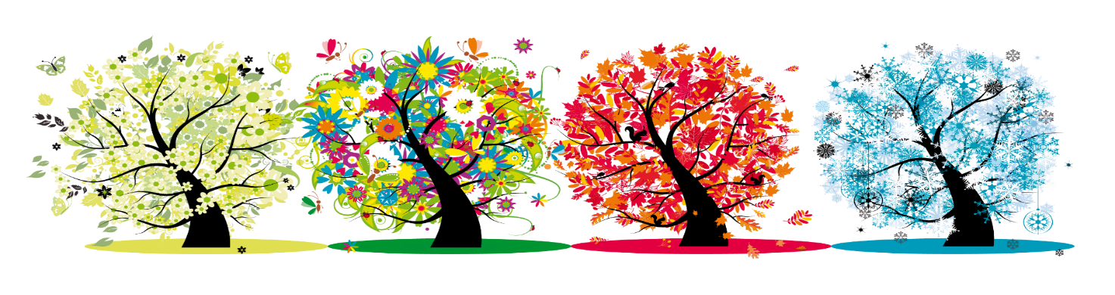**Wonderful Weather Vocabulary Mat**

|  |  |  |
| --- | --- | --- |
| Winter  Autumn  Summer  Spring | | |
| **Meteorologist**  A person to predict the weather. | **Forecast**  An overview of the weather for the coming week or month. | **Temperature**  How hot or cold we are? |
| **United Kingdom** | **England** | **Drizzle** |
| **Thermometer** | **Rain Gauge**  Image result for rain gauge | **Weather vain**  Image result for weather vane |