**DT**

Roman Porridge

Growing and processing oats

Health benefits of oats

Market research of existing porridge products and flavours

Design new porridge flavour, list ingredients and equipment needed.

Draw flow chart showing sequence of actions needed to make porridge.

Make and evaluate porridges

**English**

Read and analyse a written account of Caractacus’ Last Battle.

Write own account of a Roman vs Celt battle.

Non-fiction – information book about Romans.

Kennings poetry about Boudicca

MC900412408[1]

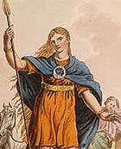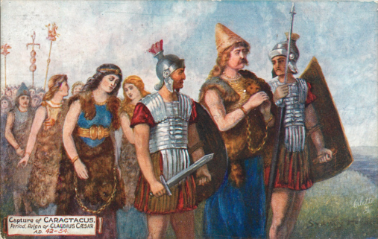MC910217119[1]MC900149420[1]

**Class 4**

**‘How did the Romans conquer Britain?’**

Spring 1

**History**

To develop an understanding of chronology

Trip to Ribchester 23/01/20

Find out about the lives of Iron Age Celts living in Britain.

Roman invasions of Britain – Julius Caesar and Claudius

Roman Soldiers – armour and weapons

Roman Forts and defences

Hadrian’s Wall

Celtic resistance – Boudicca

The fall of the Roman Empire

What did the Romans do for Britain?