Hot and Cold Places Vocabulary Mat
North Pole  the northern most place on earth  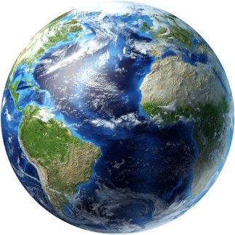  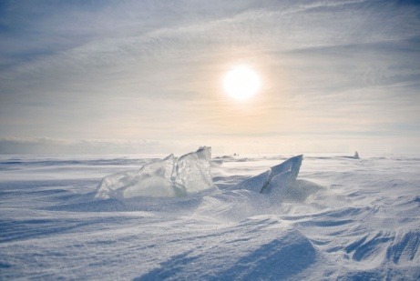 |  |  | Equator  an imaginary line around the centre of the earth  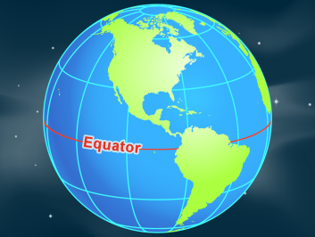
South Pole  the southernmost place on earth  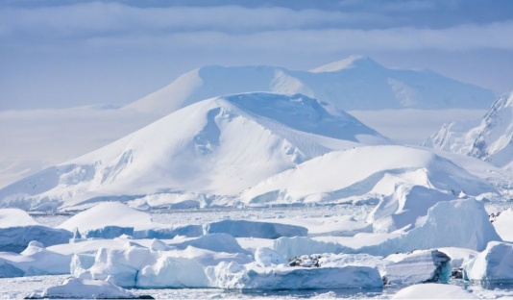 |  |  | rainforest  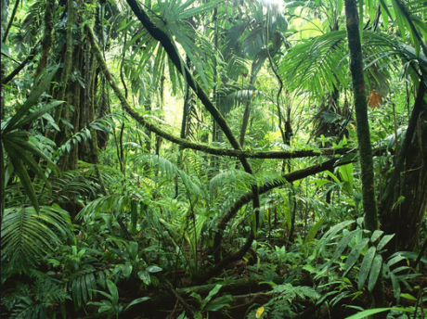
sand dune  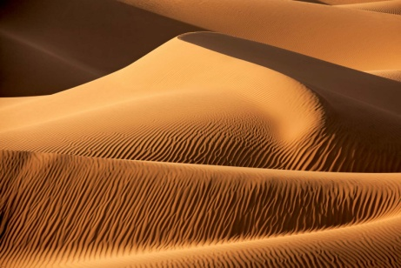 | ice berg  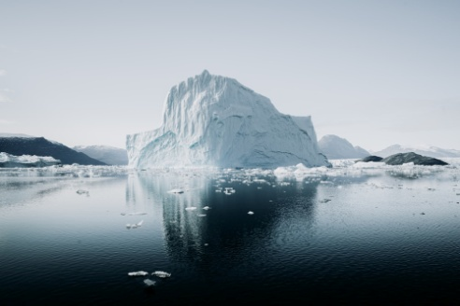 |  | desert  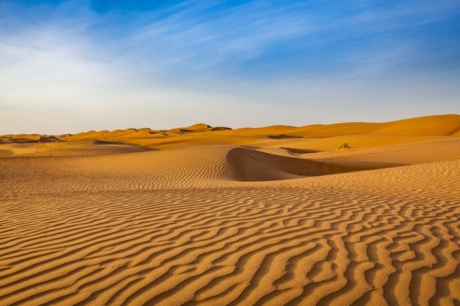
animals that live in cold places  penguins  polar bears  Arctic fox  seal  reindeer  walrus  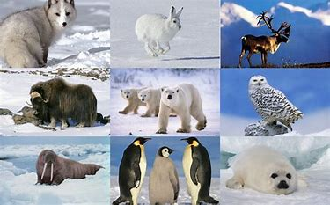 |  | 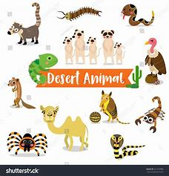  animals that live in hot places  Meerkats  Lizards  Scorpion  Coyote  Camel

