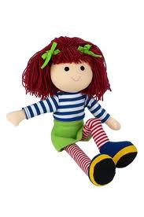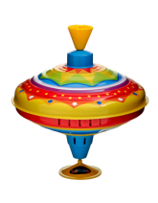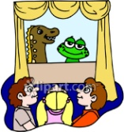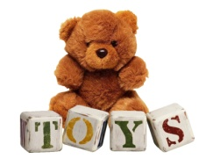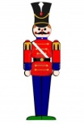[](http://images.google.co.uk/imgres?imgurl=http://oswalrishta.com/new/Pharmazone/images/laptop-icon.gif&imgrefurl=http://oswalrishta.com/new/Pharmazone/apply_now.php&usg=__F5NznrKVNb4_coYoqtv63dBK644=&h=78&w=72&sz=5&hl=en&start=4&itbs=1&tbnid=6cUDnSS0ywME7M:&tbnh=73&tbnw=67&prev=/images?q=laptop+icon&hl=en&gbv=2&tbs=isch:1)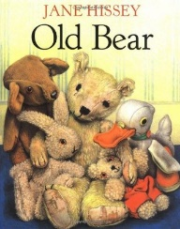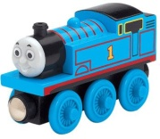

## **Art/Design Technology**

* Charcoal and pencil drawings of old/new teddy bears
* Design and make a puppet

## **History**

* Ask and answer questions about toys and games from the past
* Compare similarities and differences between toys from the past and newer toys
* How do we know if toys are old or new
* Describe toys from the past

## **Computing**

* Finding information search engines on internet linking to history topic – Toys
* Staying safe online

## **PE**

* Games and ball skills
* Dance – exploring how different toys move

## **Science**

* Plants – Seeds and Bulbs
* Materials – uses of everyday materials
* What are toys made out of?
* Investigate what is the best material for a bath time toy?
* Forces – Pushes and pulls
* Investigate how to make a toy car move furthest?

**Class 2 - Spring 1**

**What were toys like in the past?**

## **English**

* Story writing based on *Old Bear* by Jane Hissey
* Information text – Toys