As Readers and Writers, we will be studying texts linked to our curriculum topics. We will read and write stories with familiar settings, Greek myths, a battle account, stories with an environmental message, a new adventure for Harry Potter and a story about a journey.
We will study and write non-fiction too – non-chronological reports, newspaper reports, diary entry, persuasive adverts and a non-fiction book. We will read, perform and write seaside poetry, Kennings and rhyming poems.
We will develop our reading, spelling and grammar skills through daily practice.
As Mathematicians, we will be looking at these key areas throughout the year: place value, addition and subtraction, multiplication and division, fractions and decimals. We will also be finding out about 2D and 3D shapes, measures and statistics.
As Geographers, we will be studying the impact of the Illuminations and tourism on Blackpool. We will undertake fieldwork to discover positive and negative impacts to the town and the people who live there. We will find out what Blackpool Council has done over the years to improve Blackpool as a tourist destination. We will follow routes on maps and also create tourist maps adding images and information.
We will find out about the effects of plastic on our oceans and wild life. By studying Henderson Island in the South Pacific we will see how single use plastic gets into the oceans and the problems it causes. We will find out ways we can reduce our use of single use plastic. We will explore how industry in different countries are approaching the problem of plastic pollution and are finding innovative ways to remove plastic from the oceans.
We will learn about different types of settlement and the patterns they create using night time satellite photographs. We will discover why world cities are growing larger and larger. We will learn why people migrate within and between countries and explore the reasons why people become refugees and how that affects their lives.

As Scientists, we will be using our investigative skills in the following areas:
Living things and their habitats – we will group living things and use classification keys.
Animals including humans – we will learn about the function of our digestive system and teeth. We will construct and interpret food chains.
States of matter – we will learn about solids, liquids and gases and investigate how materials can be changed by heating and cooling.
Sound – we will identify how sounds are made. We will explore pitch and volume and recognise sounds grow fainter as they travel from their source.
Electricity – we will construct simple circuits including switches and recognise insulators and conductors.

We will continue to develop our language skills in French, with a focus on speaking and listening and learning key everyday vocabulary. We will also begin to read and write words and phrases in French.

In R.E we will deepen our understanding of Jesus – who he was, his teaching and behaviour. We will understand the Christian belief that Jesus is the ‘Light of the World’ and how He brings light into people’s lives. We will explore the story of David and his strengths and qualities. We will discover more about the nature of God by reading Psalms. We will focus on incidents of betrayal and trust at Easter. We will make comparisons with other religions e.g. Islam and Judaism..
As Designers, we will use our skills to research, design, make and evaluate to create a working illumination using electrical systems, a brand new flavour of porridge not yet available in shops and a textile collage of a habitat and an animal that lives there.

As Historians, we will find out why the Classical Age of Ancient Greece was so important. We will discover how and why the Romans conquered Britain and visit the Roman museum and ruins at Ribchester. We will find out about the Pendle Witches and decide whether they were wrongly accused. We will use appropriate vocabulary when discussing, describing and explaining historical events. We will select and organise relevant historical information from sources including dates and terms. We will choose the most appropriate way of communicating different historical findings.
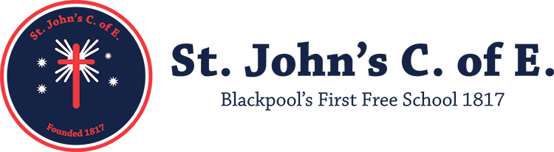
St John’s Class 4 Curriculum 2019/2020
In P.E, we will continue to apply and develop a broad range of skills, using them in different ways. We will enjoy communicating, collaborating and competing with each other whilst playing competitive games such as handball. We will develop flexibility, strength, technique, control and balance through athletics and gymnastics. In dance we will use a range of movement patterns. We will enjoy outdoor activities and learning to swim.

In PSHE, we will continue to develop our own personal, social and health education through these topics: ‘Me and My Relationships’,’ Valuing Difference’, ‘Keeping Myself Safe’, ‘Rights and Responsibilities’, ‘Being my Best’ and ‘Growing and Changing’.

As Coders and Responsible users of ICT, we will develop our knowledge and skills in Espresso coding and Scratch. We will learn about computer networks and how to use the apps on Google Drive responsibly. We will create multimedia movies.
Most importantly, we will make sure we always stay safe online and know how to achieve this.
As Musicians, we will be improving our singing and instrumental skills throughout the year. We will listen to a range of composers and respond to their compositions. We will also start thinking about own composing.
As Artists, we will use sketchbooks to research, practice and develop our skills in drawing, printing, 3D and digital media. We will work with a variety of media on different scales using the work of artists and craftspeople to inspire us. We will make and paint Greek amphoras and paper mache theatre masks. We will use plastic waste to print sea turtles onto ocean backgrounds. We will create Andy Warhol style witch faces using digital media.

