As Mathematicians, we will be looking at these key areas throughout the year: place value, addition and subtraction, multiplication and division, fractions and decimals. We will also be finding out about 2D and 3D shapes, measures, and statistics.
As Readers and Writers, we will be studying texts throughout the year linked to our curriculum topics. Covering historical stories, stories with a dilemma, character and setting descriptions, mystery and adventure stories.
We will also be writing non-fiction texts such as discussion and non-chronological reports. We will continue to read and perform poetry.
We will develop our reading, spelling and grammar skills through daily practice.
As Geographers, we will be learning about the different regions of the United Kingdom and taking an in-depth look at the county of Lancashire. We will be focussing on the human and physical features of both the urban and rural areas of Lancashire.

We will learn what causes volcanoes and earthquakes to occur and what global impacts volcanic eruptions and earthquakes have. We will also explore what life is like for those people who live in areas that are affected by both of these natural phenomena.

We will be studying the geography of the Amazon basin, in particular the Amazon Rainforest. We will be starting to learn how the future of tropical rainforests and other eco systems is closely connected to human lives and lifestyles. We will also be learning about the wider country of Brazil in which most of the Amazon Rainforest is located.

As Scientists, we will be using our investigative skills in the following key areas:
Animals, including humans - identifying that animals cannot make their own food and get their nutrients from what they eat, and exploring the skeleton and its functions.
Rocks - learning about the three different rock types, describing and classifying them and knowing how fossils are formed.
Light - learning about how light travels and observing reflection and shadows.
Forces and magnets - investigating how magnets act and on with what materials they work.
Plants - indentifying parts of the plant, exploring what plants need for life and growth, and investigating the way in which water is transported within plants.

As Designers, we will be designing, making and evaluating healthy salads (cooking), building shadufs (mechanical systems) and building Mayan pyramids (structures).
In RE, we will be considering what it means to be called by God, gaining insight into the impact that Jesus had/has on people's lives and considering the value and purpose of rules. We will also be considering the rules followed by other faiths. We will also be learning about major Christian festivals such as: Harvest, Christmas and Easter.
We will continue to develop our language skills in French, with a focus on speaking and listening and learning new key everyday vocabulary. We will also begin to read and write words and phrases in French.

St John’s Class 3 Curriculum 2019/2020
As Historians, we will study what life was like for people in the Stone Age, Ancient Egypt and Ancient Maya.. We will use appropriate vocabulary when discussing, describing and explaining historical events. We will select and organise relevant historical information and sources including appropriate dates and terms. We will choose the most appropriate way of communicating different historical findings.
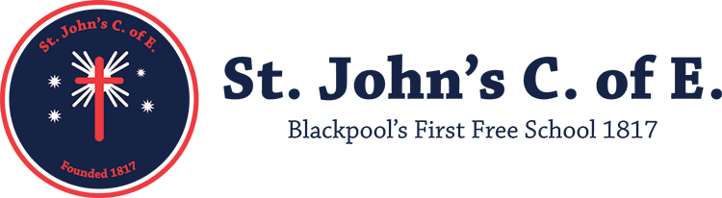
In PSHE, we will continue to develop our own personal, social and health education through these topics: Healthy lifestyles, Keeping safe, Growing and Changing, Healthy Relationships, Rules, rights and responsibilities and Caring For The Environment.

In P.E, this year, we will be developing our skills in the following areas: athletics, dance, gymnastics, invasion games, striking and fielding. We will focus on developing our individual skills as well as our ability to work successfully in teams/groups of different sizes.

As Coders and Responsible users of ICT, we will develop our knowledge and skills in the use of Espresso Coding, using the internet as a research tool and as a means to communicate through blogs and email. We will also be learning about computer networks and the creation of multimedia.
And importantly, making sure we are always staying safe online and know how to achieve this.
As Artists, we will be developing our techniques in drawing and paint, using our sketch books to record and revise ideas. We will be looking at the work of abstract artists such as Kandinsky and Jackson Pollock, as well as the work of Henri Rousseau. We will also spend the year looking at a variety of artists and designers as well as working within different media and using a range of techniques.
As Musicians, we will be improving our singing and instrumental skills throughout the year. We will listen to a range of composers and respond to their compositions. We will also start thinking about own composing.

