As Mathematicians, we will be looking at these key areas throughout the year: place value, addition and subtraction, multiplication and division, fractions and develop our number sense. We will also be finding out about 2D and 3D shapes, measures and statistics.
As Geographers, we will be learning about hot and cold countries and exploring similarities and differences between the regions with an emphasis on learning about animals that survive there and weather patterns.
We will be learning about human and physical geography. We will learn vocabulary such as (physical) ocean, sea, mountains, desert and (human) village, town, city, factory etc.
We will be taking a first look at the 7 continents of the world and beginning to name oceans and seas.

As Readers and Writers, we will be studying texts throughout the year linked to our curriculum topics. Covering traditional tales, fables and stories from other cultures, character and setting descriptions, space, fantasy and adventure stories. We will also be writing non-fiction texts such as discussion and non-chronological reports. We will continue to read and perform poetry.
We will develop our reading, spelling and grammar skills through daily practice.

As Scientists, we will be developing and using our scientific investigative skills throughout these science topics:
-Identify and name a variety of common wild and garden plants, including deciduous and evergreen trees. Also we will identify and describe the basic structure of a variety of common flowering plants, including trees.
-Name a variety of everyday materials, including wood, plastic, glass, metal, water, and rock and describe the simple physical properties of a variety of everyday materials. We will compare and group together a variety of everyday materials on the basis of their simple physical properties.
-Identify and name a variety of animals including fish, amphibians, reptiles, birds and mammals. Identify animals that are carnivores, herbivores and omnivores.
-We will name, draw and label basic parts of human body and develop our understanding of our senses.
We will also be leaning about seasonal changes.

In RE, we will find out about different Christian festivals Harvest, Christmas and Easter.
We will visit the Synagogue and learn about the Jewish festival of Sabbat.
We will talk about Jesus’s world and Him as our friend and teacher, we will learn about Baptism and the Creation story.

As Designers, we will design, make and evaluate different projects.
We will build a house for a hedgehog.
We will make banana smoothies and vegetable soup (we will discuss healthy living).
We will design our own fairy garden and woodland mobile.

St John’s Class 1 Curriculum 2019/2020
As Historians, we will study what life was like for children who lived in castles, we will take a trip to Lancaster castle and learn about the battle of Hastings.
We will learn all about the Victorian seaside and how holidays became a part of family life.
We will learn about significant people in history such as Neil Armstrong, Tim Peakes, Queen Victoria and Harold Godwinson.
We will learn to use different historical sources to discover and learn about the past.
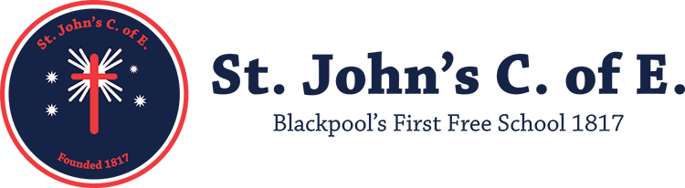
In PSHE, we will continue to develop our own personal, social and health education through these topics: Healthy lifestyles, Keeping safe, Growing and Changing, Healthy Relationships, Rules, rights and responsibilities and Caring For The Environment.

In P.E, this year, we will be learning ball skills, developing our throwing and catching skills, dance and gymnastics especially balancing and rolling. We will be learning about athletics and how to participate in team sports. We will take part in yoga sessions and learn about healthy bodies and healthy minds.

As Artists, we will be developing our techniques in drawing and paint, using our sketch books to record and revise ideas. We will be looking at the work of Paul Klee, Vincent Van Gogh and Andy Goldsworthy. We will also spend the year looking at a variety of artists and designers as well as working within different media and using a range of techniques.
As Musicians, we will be improving our singing and instrumental skills throughout the year. We will listen to a range of composers and respond to their compositions. We will also start thinking about composing our own pieces of music.
As Coders and Responsible users of ICT, we will develop our knowledge and skills in word processing, I pad use, programming with bee-bots and discovery education, how to turn a computer on and off, logging on and off safely. Most importantly, making sure we are always staying safe online and know how to achieve this.

