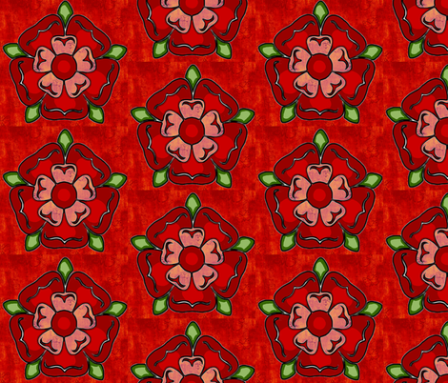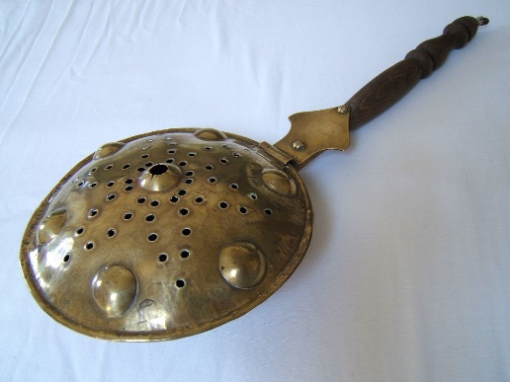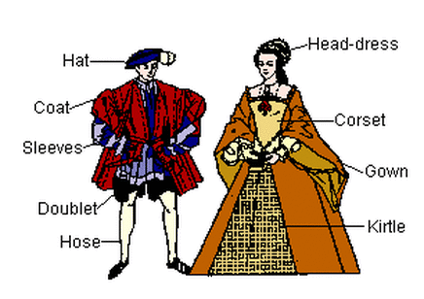

**Tudors!**

Bed warmer

Gallows

Horse and plough

scythe

Monarch

Reign

Heir

Dynasty

Battle of Bosworth

Tudor Rose

Henry Tudor

Henry VIII

Elizabeth I

Sir Walter Rayleigh

Church of England

Wives

Beefeater

gown

chemise

kirtle

corset

French hood

Ruff

Farthingale

Doublet

Breeches

Hose

Wattle and daub

Timbered

Banquet

