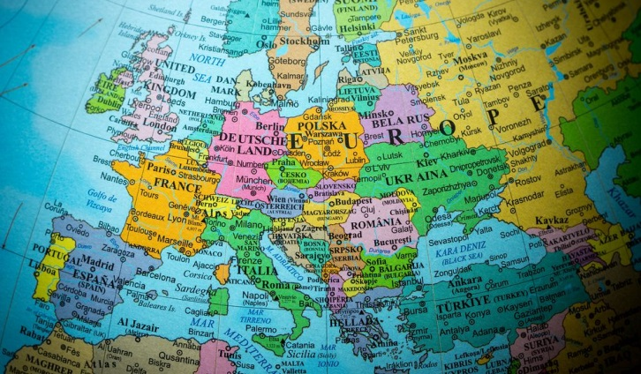

**Europe- France Word Mat.**

Border

Climate

Area

Population

Rural

Urban

Land-use

Characteristics

Features

Human Features

Town

Village

Shop

Church

Factory

Office

Farm

Harbour

Port

Canal

Physical Features

Weather

Beach

Coastline

Forest

Hills

River

Mountains

Cliff

Forest

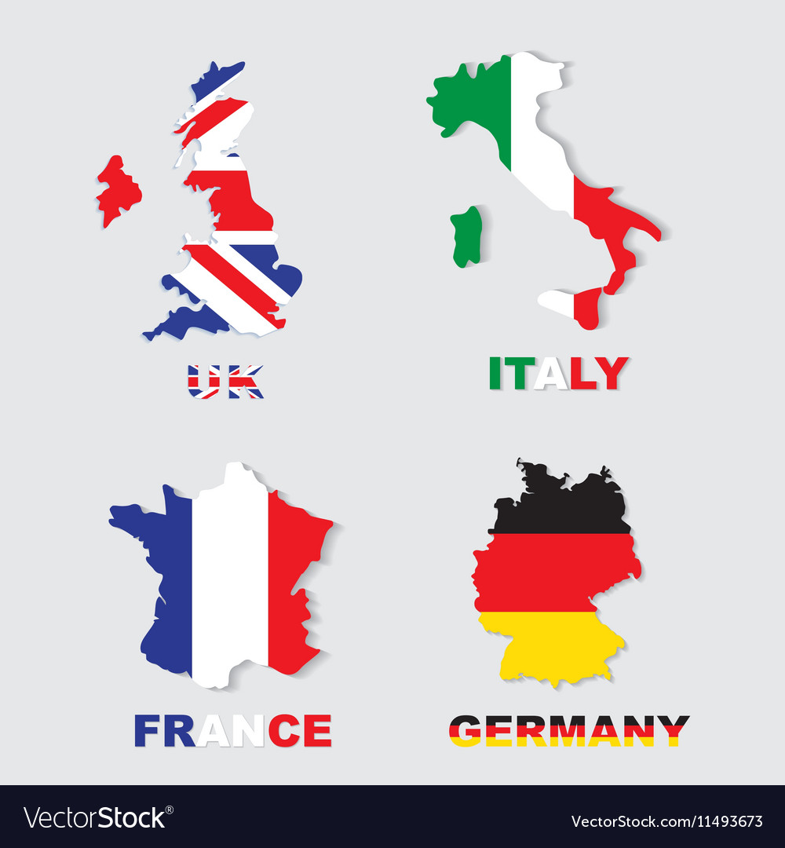

Europe

France

Britain

Blackpool

La Rochelle

London

Paris

Country

Cities

Coast

