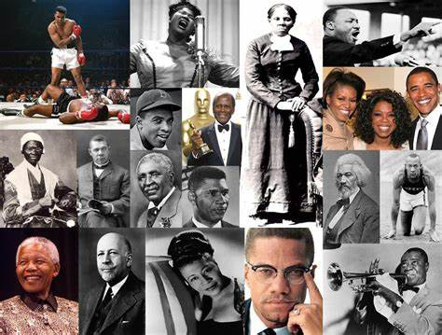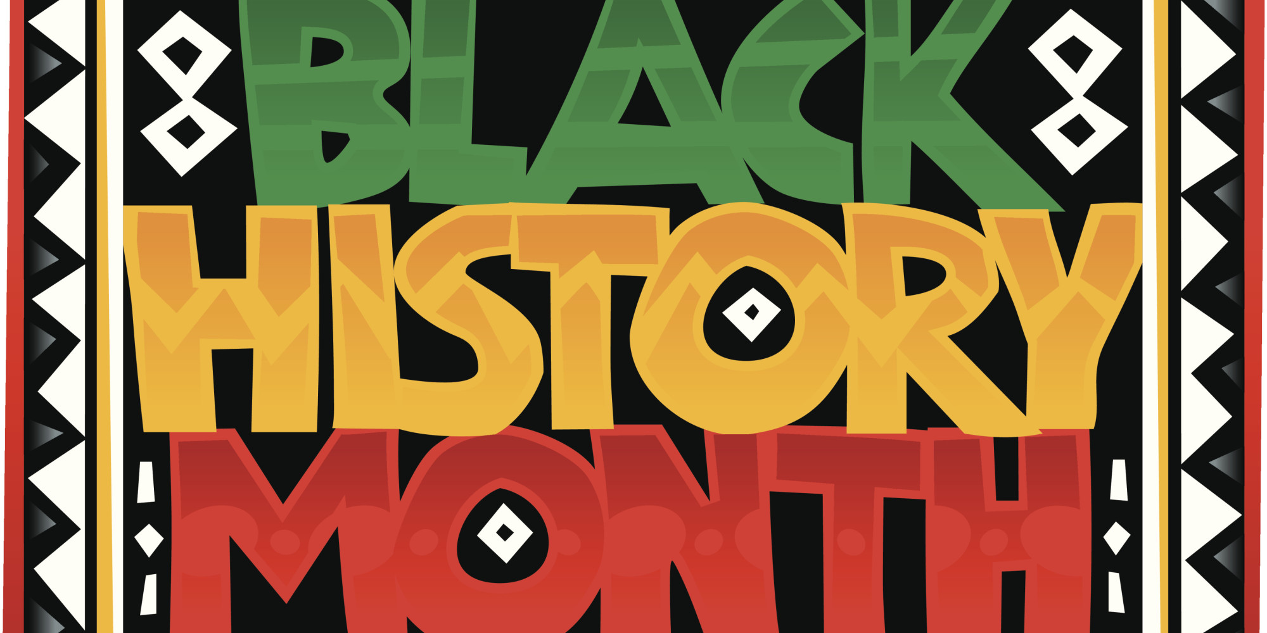

**Black History Word Mat**

Britain

Protest

Activist

Prejudice

Segregation

Integration

Slaves

Discrimination

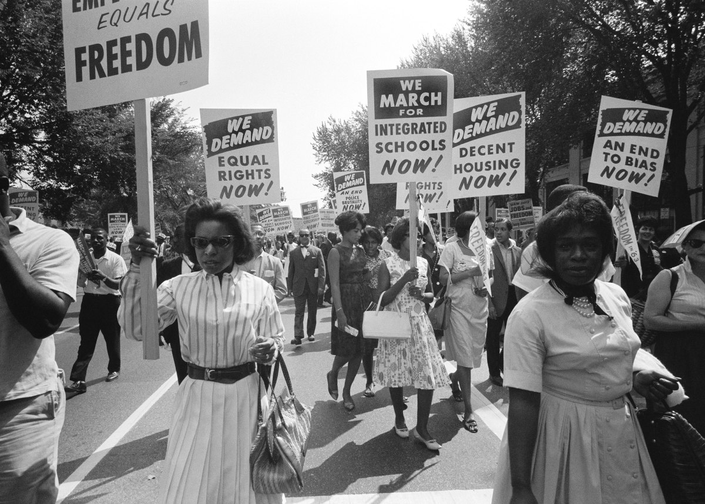

Freedom

Equality

Civil Rights

Justice



Caribbean

Jamaica

Havana

Cuba

Bermuda

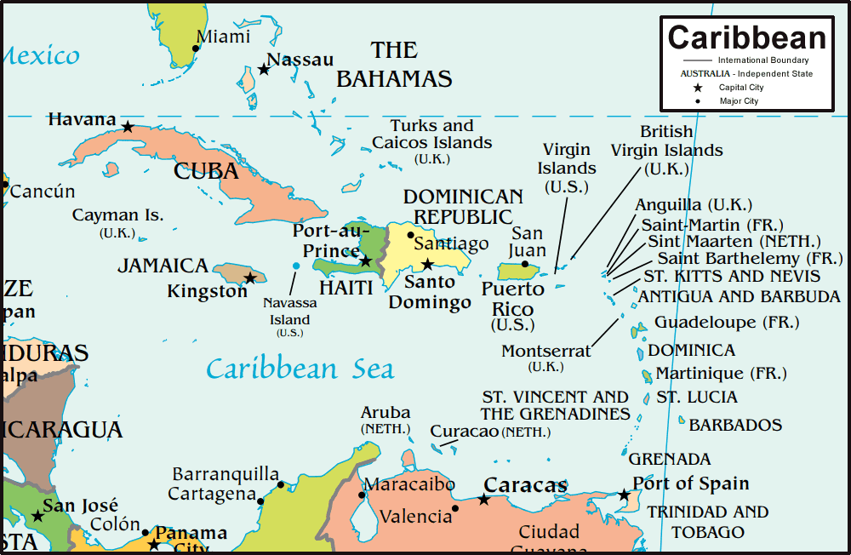

Africa

Nigeria

Ghana

Zimbabwe

Kenya

