**A Region in North America**

**Yellowstone National Park**

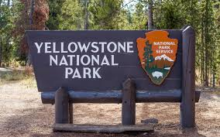Class 6 - Spring 2

**North America**

Continent

ocean

hemisphere

latitude

landscape

region

significant

**Yellowstone National Park**

Physical Features

geyser

geothermal

mountain

volcano

climate

vegetation

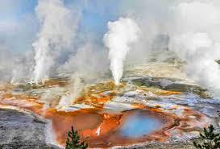

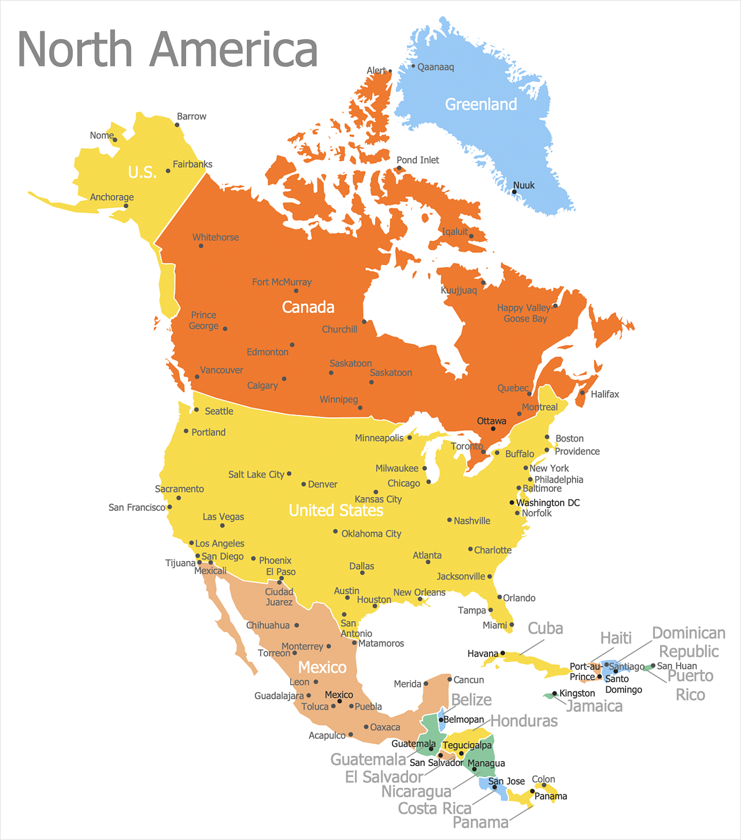

Human Features/Activities

employment

tourism

attraction

location

visitor

conservation

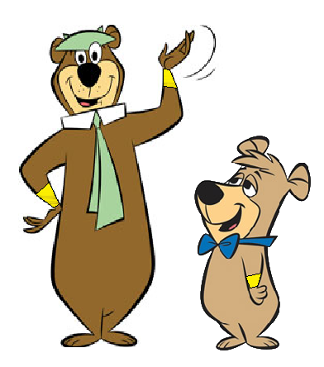

Welcome to Yellowstone National Park!

Thanks Yogi – but we actually live in Jellystone National Park.