# *Witches and Potions* – key vocabulary

**History**

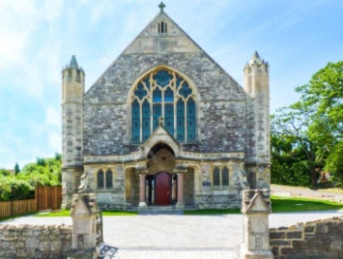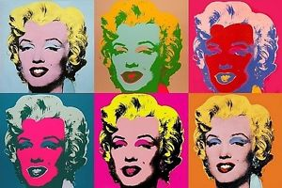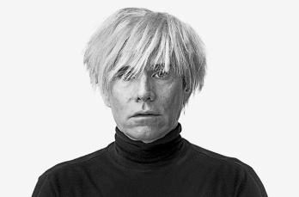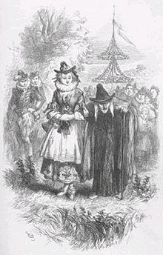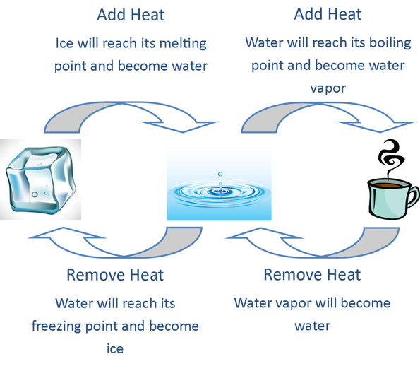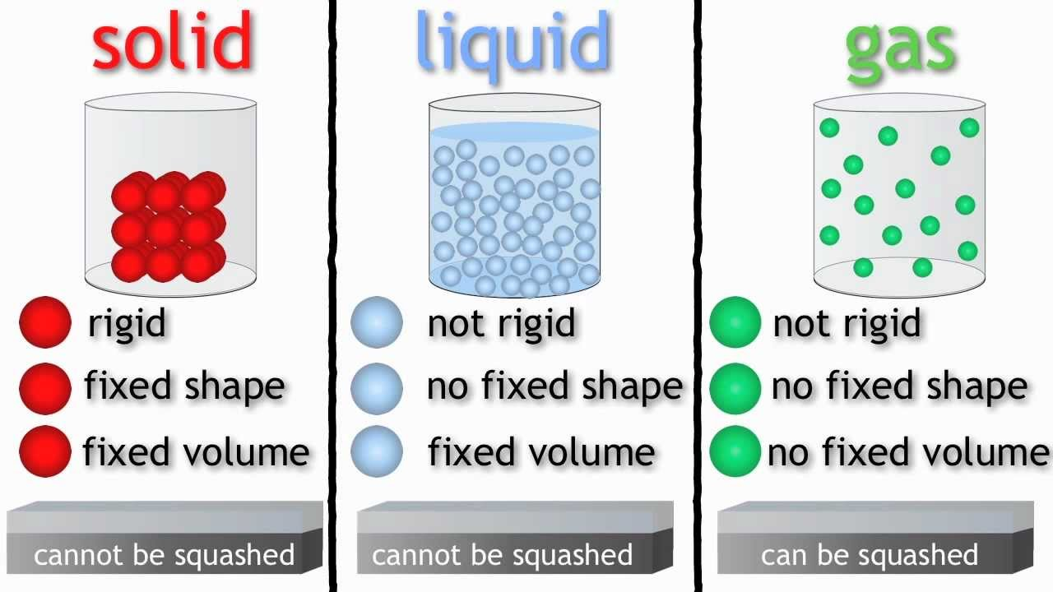

Church

Vicar

Denomination

Cathedral

Sacrament

Andy Warhol

Pop art

Digital media

Filter

Picasso

Pendle Hill

Lancaster Castle

Trial

Witchcraft

King James I

Century

Malkin Tower

Spell

Charm

Familiar