long boat

sword

shield

helmet

axe

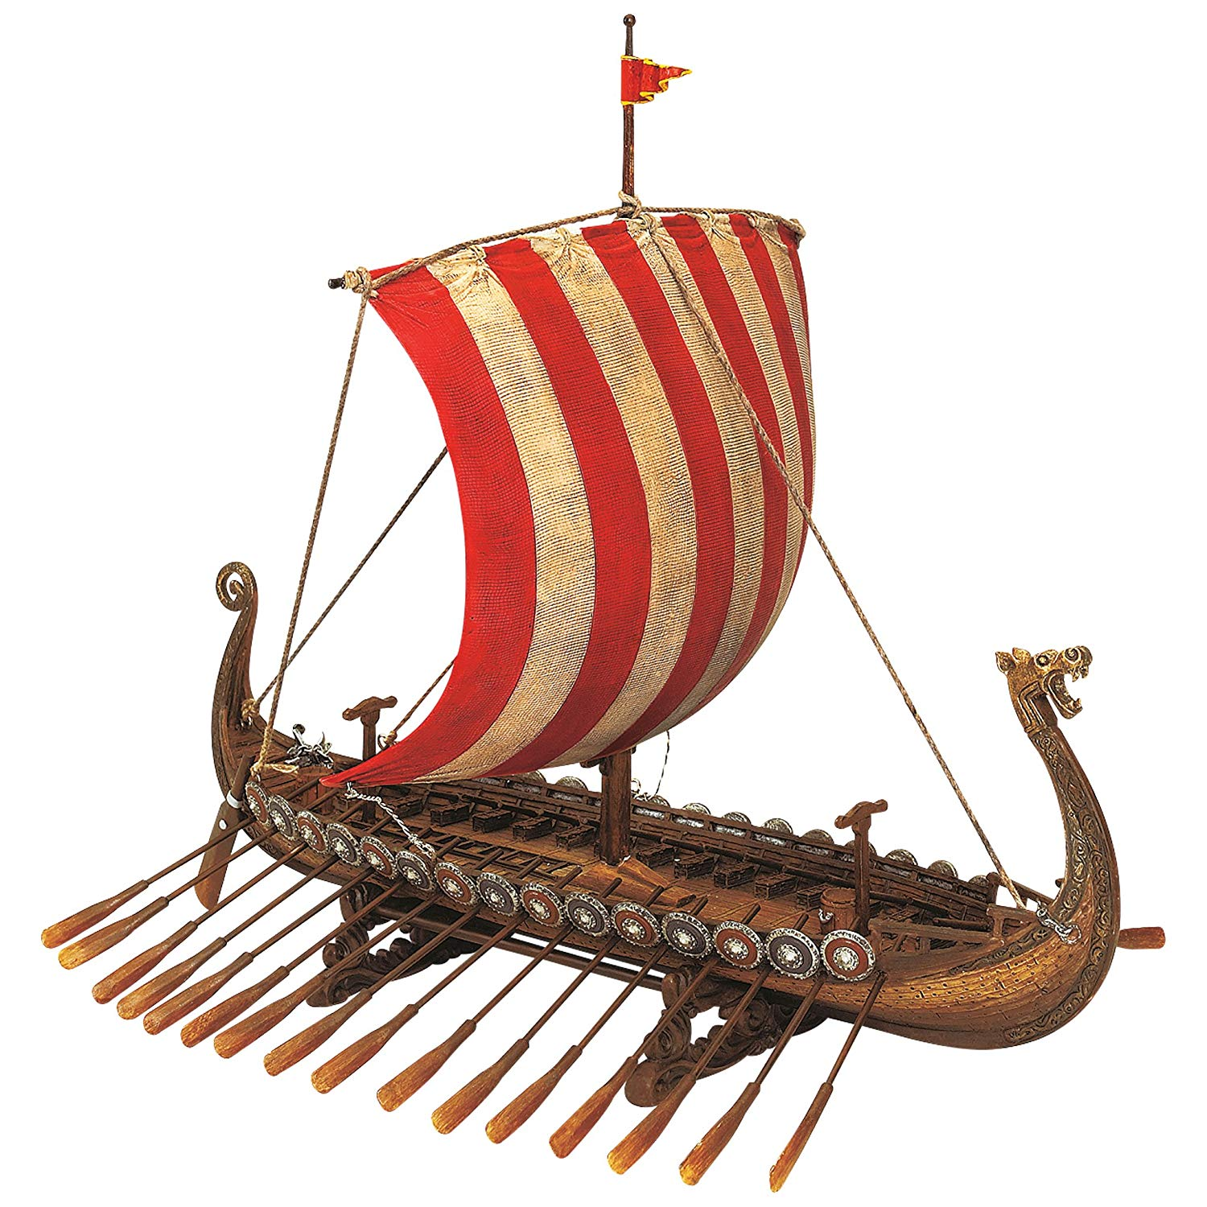

Anglo-Saxon

Viking

warrior

invader

settler

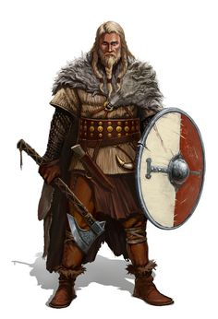

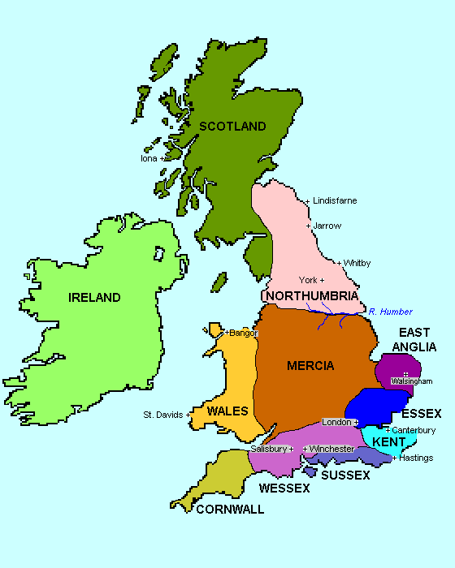

**Places**

Scandinavia

Denmark

Norway

Britain

England

Northumbria

Wessex

Mercia

Kent

East Anglia

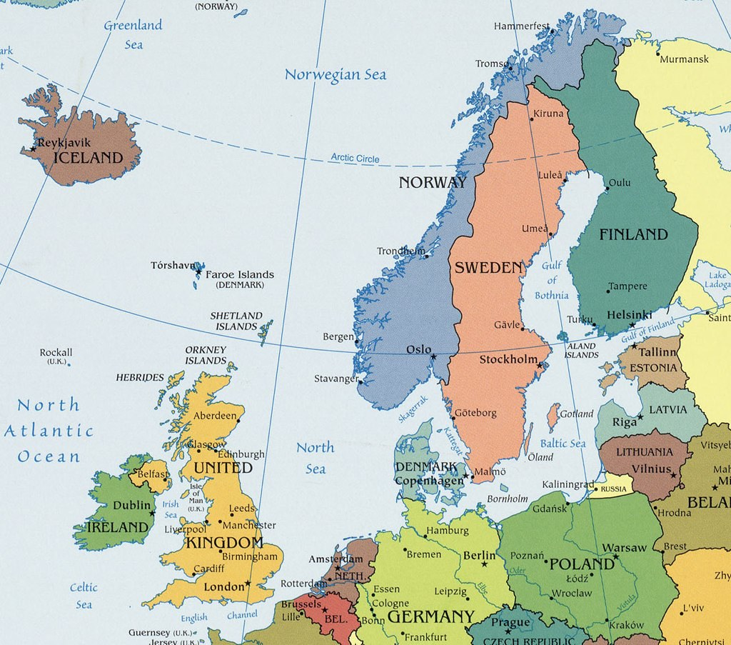

Viking Word Mat

settlement

longhouse

loom

coins

drinking horn

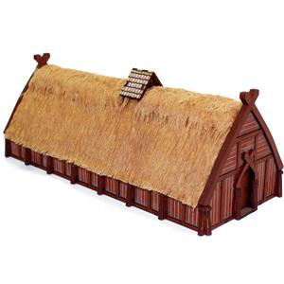

conquer

merchant

agriculture

craftsman