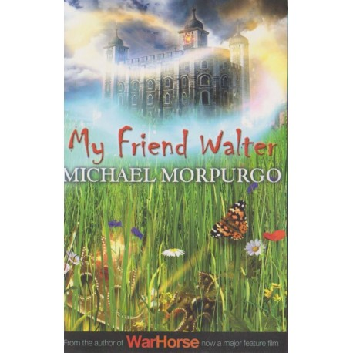

History

* To locate Tudors in history and on a timeline, and understand the houses of York and Lancaster.
* Battle of Bosworth leading to the coronation of Henry Tudor and the start of the Tudor dynasty.
* The importance of the Tudor Rose today.
* To understand the Tudor dynasty looking at Henry VIII
* To explore the legacy of the Tudors – Church of England.
* To research an area of Tudor life and discuss how it was different for the rich and poor.

English

* To recreate the story ending of My Friend Walter.
* To explore and create accounts and biographies from the Tudor period.
* Class novel: Short stories by Shakespeare

Art

* To explore the roles and purposes of artists, craftspeople and designers working in Tudor times – batik artists.
* To create the Lancashire Rose using difference materials.

**Tudors**

**Class 5**

**How did the Tudor dynasty begin and what legacy did it leave?**

**WOW FACTOR**

**Tudor workshop!**

**Visit to Towneley Hall!**

