English
- Vocabulary, Spellings and Grammar
- Class read – My Friend Walter
- Newspaper report
- Information Text

Science
Earth and Space
- The names and order of the planets in the Solar System
- How the planets rotate around the sun and how Earth has night/day and the seasons
- The phases of the moon

Maths
- Mental maths and times tables
- Mental and written division
- Coordinates
- 2d and 3D shape including sorting
- Geometry
- Word problems involving all 4 operations

History
- Who were the Tudors
- Learning about Henry VIII and his wives.
- Learning how the Church of England was formed.
- Finding out what some famous Tudors accomplished.
- Ask

The Tudors
Who were the Tudors and what did they accomplish?

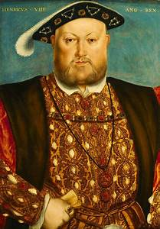

PE
- Swimming
- Dance

RE
- Women in the Bible (continued from last half term)
- Why do Christians believe that Easter is a celebration of victory?

PSHE
- Relationships

French
- Language Angels - Pets

Art
- Experiment with a range of media and textiles to create a Tudor Rose.

Music
- Dancing in the street - motown music

Computing
- RM easimaths
- Spelling Shed
- Communication and collaboration



