**Creative Activities**

* Cold colour art work / collage
* Creating our own masterpieces with paint
* Modelling clay penguins
* Painting using different techniques
* Imaginative play around snow and ice, creatures, elves and fairies e.g. ice palaces / caves
* Create a winter wonderland from junk materials
* Making boats for penguins

**SPRING 1**

**Foundation Stage**

**The World**

* Talk about cold weather ~ snow and ice
* Observe changes in our local environment
* Children to find out about animals and people that live in cold climates
* Investigate ice both blocks and small cubes. Add colours, objects and rock salt. Observe effects.

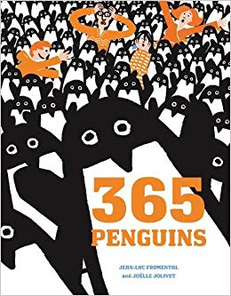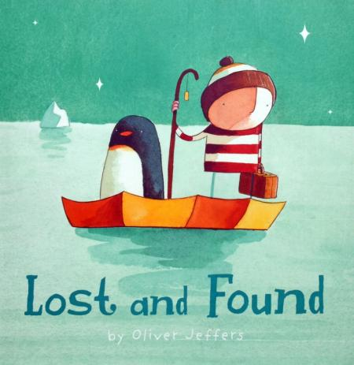

**Outdoors**

* Provide the children with open ended resources for them to explore, create and investigate with.

These may include: wooden blocks, crates, den making materials, outdoor sand and water, mark making equipment and areas to discover.

* Opportunities to explore ice as it forms naturally outside
* Observe signs of winter e.g. wearing hats/gloves, experiencing cold weather

**Books we will be sharing together to help us with our learning:**

* Betty and the Yeti
* Lost and Found
* Penguin
* Penguin Post
* Not so Perfect Penguin
* Snow Friends
* Iris and Isaac
* The Snow Beast

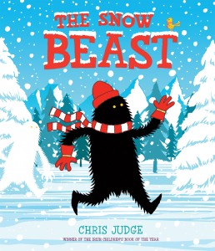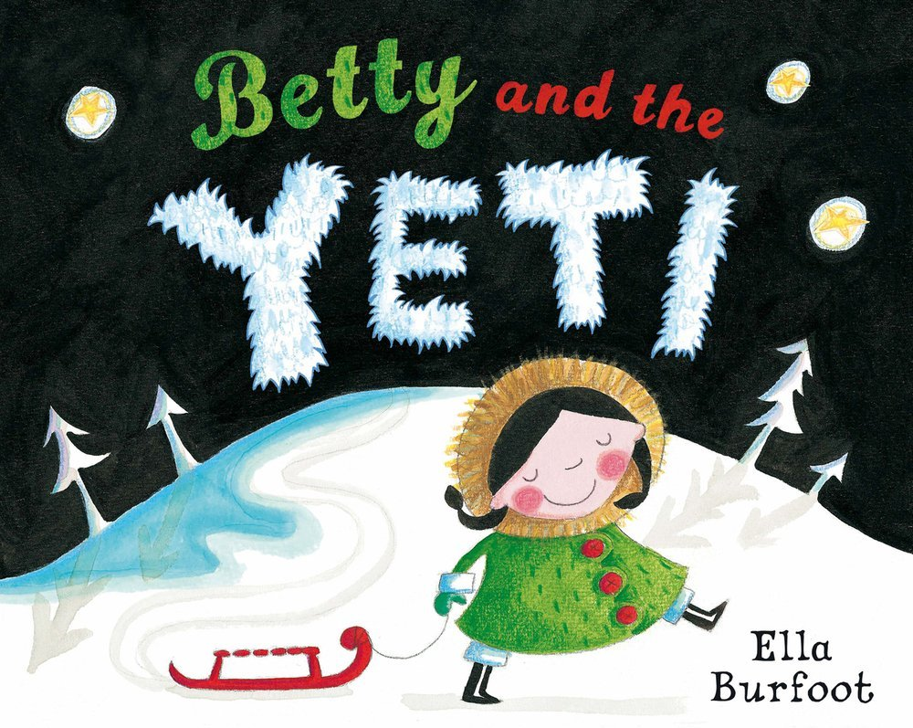

**RE ~ Stories Jesus Heard**

* Daniel in the Lion’s Den
* Joseph and his Coat of Many Colours
* Noah’s Ark
* Moses in the tall grasses

**We will also be following the children’s interests and exploring the things that are of importance to them**



**of importance to them**