**Science: Living Things and their habitats-Classification**

**-Scientist ‘Carl Linnaeus’**

**-Use/Create classification keys**

**-Trees in our local environment (Visit to Stanley Park)**

**-Finding out about unusual living things/quirky creatures**

**-Children to design, describe and name their own new creature.**

**English:**

**Text: ‘The London Eye”**

**Spelling, Punctuation and Grammar Revision**

**Reading Comprehension Skills**

**Preparation for SATs**

**French:**

**Les vetements (Clothes)**

**Maths:**

4 Operations

Applying different strategies to solve problems

Arithmetic skills

SATs Revision

**History:**

**Celebrating the 125th anniversary of Blackpool Tower**

**Describe why and how the Tower was built**

**Understand the significance of the Tower to Blackpool during the last 125 years**

***Local History - Class 6***

***Summer 1 - 2019***

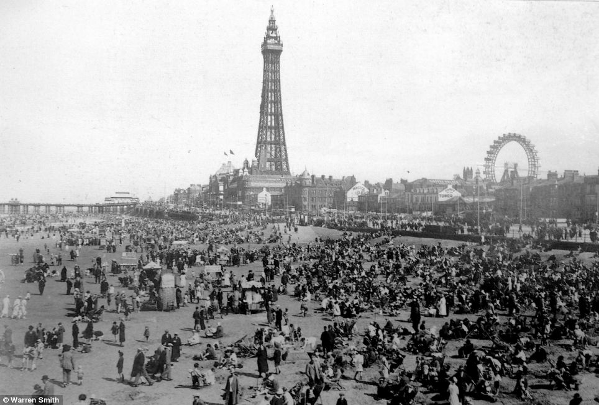

**Visits:**

**Blackpool Tower**

**Martin Mere, Burscough (Science Focus)**

**Stanley Park (Science Focus)**

**Computing:**

Developing programming and coding skills

Creating a story book

**P.E**

**-**Sport 4 Champions programme

**Sports Day**

- Developing leadership skills in PE

**R.E:**

**Ascension and Pentecost**

**Understanding why these two events are so important and their impact then and now.**

**P.S.H.C.E**

Sport 4 Champions programme

Making Healthy Choices

Benefits of an active lifestyle

Healthy Eating Choices