A Region in North America

Yellowstone National Park

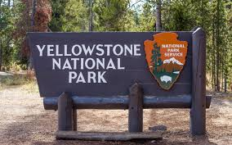

Class 6

Spring Term 2 - 2020

**English**

Reading

“Holes” by Louis Sachar

(A story based in the USA)

Identify language differences in American English.

Develop comprehension skills and inference.

Writing

Letter Writing.

Narrative Writing.

Using of dialogue, flashbacks, setting and character descriptions.

**Geography**

North America

Identify the countries of North America using different atlases, maps and globes.

Understand why the USA is seen as the most powerful country in North America.

Yellowstone National Park

Locate Yellowstone within the USA.

Identify the physical features.

Describe the climate and vegetation.

How do humans use Yellowstone?

What is the impact on the national park of human activity?

Compare Yellowstone National Park with Blackpool.

**Art**

Explore the works of landscape and cityscape artists (Thomas Hill ‘Resting by a Stream’ Yosemite)

Draw and paint landscapes linked to Yellowstone National Park.