**History**

**The Vikings**

Britain before the Vikings

Anglo-Saxon time

Viking conquerors

Invaders and Settlers

Viking Daily Life

**English**

“There’s a Viking in My Bed”

By Jeremy Strong

Describing characters

Using evidence from the text to support ideas

Exploring settings

Using descriptive language

Understanding inference

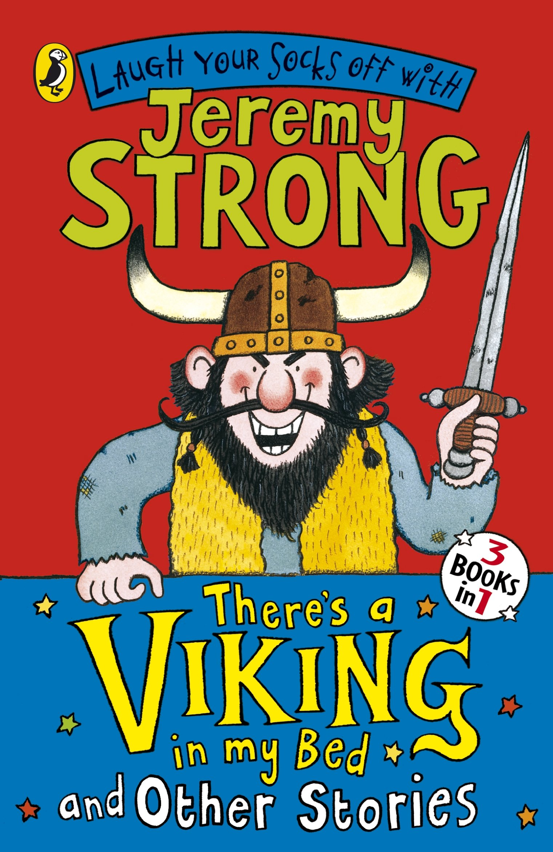

What impact did the Vikings have on Britain?

**Placing Events in History**

Using a timeline to understand when the Anglo-Saxon and Viking periods were.

**Class 5 - Autumn 1**

**The Vikings**