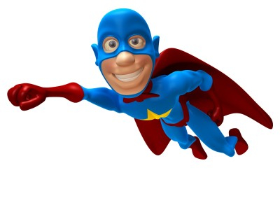
Year 1 Our school/Super hero’s – Vocabulary Mat

Our school and its locality
Location | The area that something can be found.
Map | A picture or drawing to show you where to find things.
Atlas | A book with lots of maps and information about the world.
Route | A path to take to get you from one place to another.
Direction | The path along something moves
North/East/South/West | The way you can face to tell you the way.

Super worm – our class story – Why not share it at home?
Servant | A person/animal to work or do things for you without being paid
Writhe | To move in a wriggly motion
Cunning | To be clever at tricking people
Squirm | To wriggle with your bottom
Disaster | A event where everything goes wrong
Mope | To moan and be sad

