Knowledge Organiser Year 5 – Living Things and their Habitats
amphibian | The word amphibian means two-lives. Amphibians spend their lives in the water and on land. They are cold blooded | 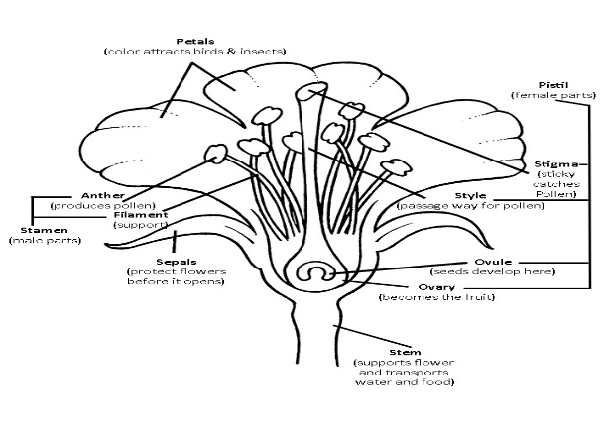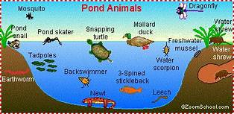  Mountain habitat  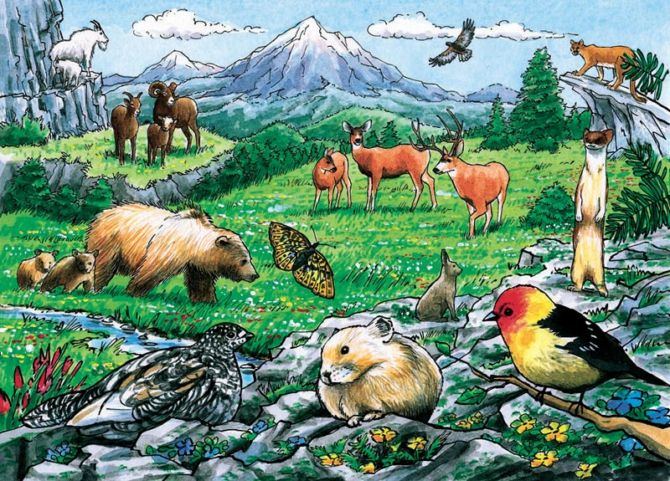
mammal | A mammal is an animal that breathes air, has a backbone, and grows hair at some point during its life. They produce living young and all female mammals have glands that can produce milk to feed their young.
invertebrates | An animal without a backbone.
camouflage | A visual disguise. Camouflage is a type of coloration or pattern that helps an animal blend in with its surroundings.
Axolotis | The axolotl is a salamander – a type of amphibian with a lizard-like body, a long tail and smooth, moist skin.
metamorphosis | Metamorphosis is a process some animals go through to become adults. It is a series of physical changes. Metamorphosis is especially common in insects.
Larvae | The word larva is applied to the young of certain animals that must undergo great physical changes before they become adults.
aquatic | In an aquatic ecosystem, that environment is water, and all the system’s plants and animals live either in or on that water.
Thorax | The thorax is one of the three main body parts of an insect. The thorax is the middle segment, behind the head and before the abdomen.
Abdomen | The part of the body between the thorax and the pelvis.
hermaphrodite | an animal or plant having both male and female reproductive tissue or organs.

