Knowledge Organiser Year 5 – European Country (Italy)
Gondola | A long, narrow, boat rowed by a single person who stands at the stem. | Geographical Coordinates: 42 50 N, 12 50 E | Mont Blanc - The highest peak in Italy at 4,810 meters above sea level. | 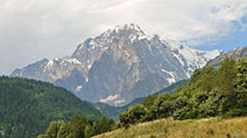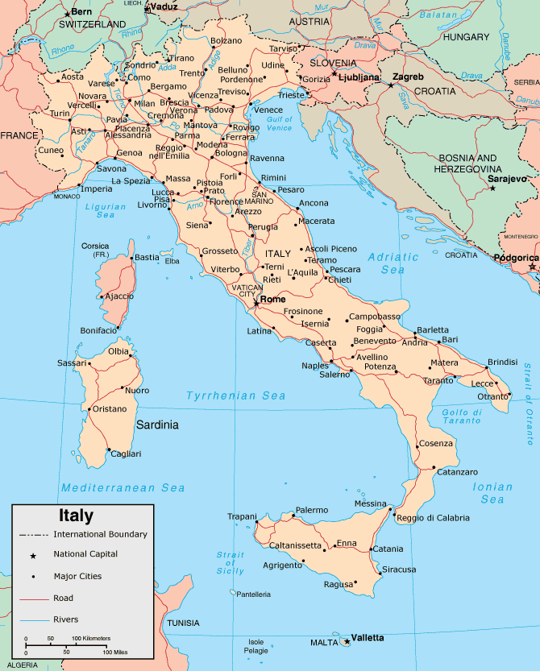
Continent | One of the main landmasses of the globe | General Terrain: mostly rugged and mountainous; some plains, coastal lowlands
Europe | A continent of the northern hemisphere | Climate: predominantly Mediterranean; Alpine in far north; hot, dry in south | Italy borders France, Austria, Slovenia and Switzerland.  It is bordered by the Adriatic Sea on the east coast, the Tyrrhenian Sea on the west or Mediterranean coast, and the Ionian Sea to the south.
Canal | A long, narrow stretch of water made for boats to travel along. | Rome is the capital city of Italy with a population of almost 3,000,000. The population of ITALY is a little over 60,000,000
Mount Etna | Largest active volcano in Europe on the island of Sicily. | 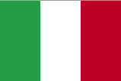  The Italian flag, called the "Tricolore", was adopted on January 1, 1948.  It has three equally sized vertical stripes of green (left), white (middle), and red (right). The green can represent hope or the green hills of Italy. The white can stand for faith or the snow-capped Alps. The red can represent charity or the blood spilt during the war for independence.
Climate | The weather conditions prevailing in an area in general.
Terrain | A stretch of land when considering it’s natural features.
Venetian Lagoon | An enclosed bay of the Adriatic Sea, in northern Italy, in which the city of Venice is situated. | 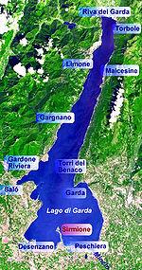  Lake Garda is  the largest lake  in Italy with a  distance round  of approximately  100 miles / 158 km. | Italy's longest river, the Po, flows 405 miles between Monte Viso and the Adriatic Sea. | 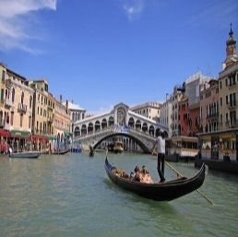  Grand Canal and the Rialto Bridge in Venice
European Union | A group of countries whose governments work together.
Landmark | an object or feature of a landscape that is easily seen and recognised from a distance, especially one that enables someone to establish their location

