Knowledge Organiser - Active Planet

Key questions:
How are volcanoes formed?
What causes an earthquake?
Key information:
How are volcanoes formed? | - Magma is formed when high temperature and pressure causes solid rock in the mantle to melt.  - When tectonic plates move, the magma is under great pressure and finds its way through the Earth's crust.  - As magma explodes through the crust, it causes a volcanic eruption. (When magma comes to the surface, we call it lava.)  - The lava cools and forms a new layer of rock/crust .  - Over time and after a number of eruptions, a volcano is formed by the build up of layers of rock/crust. |  | 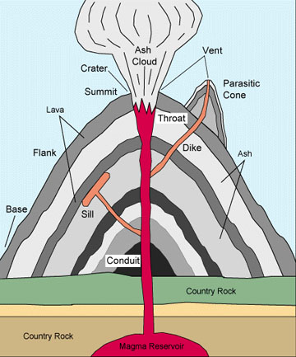
What causes an earthquake? | Earthquakes usually occur on the edges of large sections of the Earth's crust called tectonic plates. These plates slowly move over a long period of time. Sometimes the edges, which are called fault lines, can get stuck, but the plates keep moving. Pressure slowly starts to build up where the edges are stuck and, once the pressure gets strong enough, the plates will suddenly move causing an earthquake. |  | 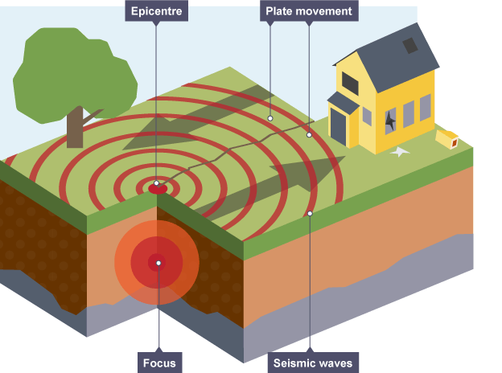
Key vocabulary: |  |  | The layers of the Earth:
Volcano - a mountain from which hot melted rock, gas, steam, and ash from inside the Earth sometimes burst. |  |  | 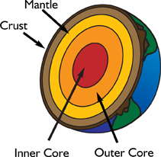
Magma - hot liquid rock found just below the Earth's surface.
Lava - hot liquid rock that comes out of the Earth through a volcano.
Eruption - an explosion of gases and lava from a volcano.
Tectonic plates - pieces of the Earth's crust that float on the mantle.
Earthquake - a sudden and violent shaking of the Earth's crust.
Epicentre - the part of the Earth's surface above the focus of an earthquake.
Focus - the point underground where the earthquake begins.
Seismic waves - waves of energy created by an earthquake.
Richter scale - the scale used to measure the power of earthquakes.
Famous Volcanoes: |  | Famous Earthquakes:
Mount Vesuvius (Italy)  Mount Etna (Italy)  Krakatoa (Indonesia)  Mount St. Helens (U.S.A)  Eyjafjallajökull (Iceland) |  | Valdivia (Chile)  Tōhoku (Japan)  San Francisco (U.S.A)  Prince William Sound - Alaska (U.S.A)  Haiti

