Spring
The season is Spring
It is getting warmer
Can you see any signs of spring?
Key Vocabulary
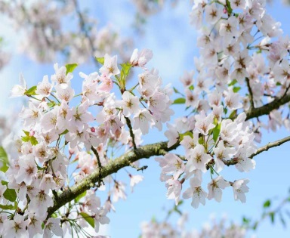  Blossom | Flowers on a tree.  we have a blossom tree in our reception garden. | 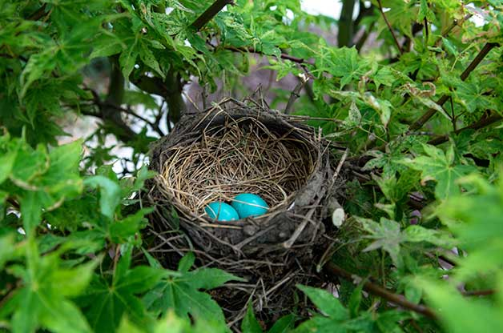  Nest | A bird builds a nest and then lays its eggs inside. It is where their babies hatch.
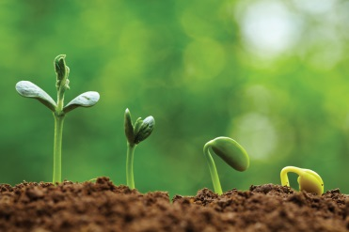  Growing | We see lots of plants and flowers starting to grow. | 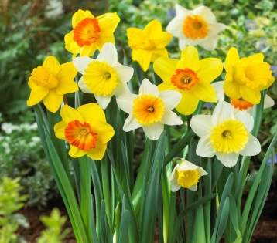  Daffodils | A spring flower. It has bright yellow petals and a trumpet like centre.
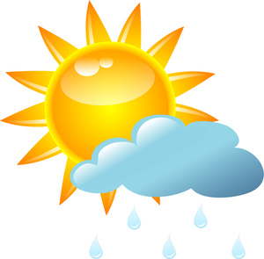  Weather | The weather can be a mix of sunshine and rain showers.  It starts to get a bit warmer outside. | 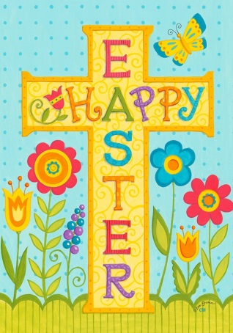  Easter | Easter is a special time for Christians. Can you share the Easter story with someone at home?
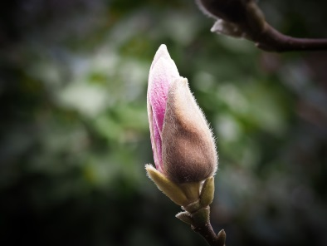  Bud | A bud is a flower or leaf which is waiting to open. | Can you go on a walk and look for signs of spring in the park or talk about the things you notice on the way to and from school?  