States of Matter – Knowledge Organiser Year 4 Summer 1
KEY VOCABULARY |  | 3 MAIN FORMS OF MATTER | KEY FACTS
matter | Matter makes up everything in the Universe in some way, shape or form. | 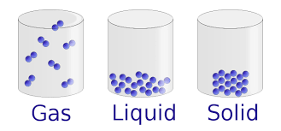 | - The boiling point of water is 100°C  - The melting point of ice is  0°C
solid | A solid holds its shape and always takes up the same amount of space.
 |  |  | EXAMPLES
 |  |  | SOLIDS | LIQUIDS | GASES
liquid | Liquids take the shape of the container they are in. They can flow or be poured. |  | ice  wood  sand  sponge  apple | water  honey  blood  paint  rain | air  steam  oxygen  helium  ozone
gas | Gas spreads out to completely fill the space they are in.
temperature | Temperature is a degree of hotness or coldness that can be measured using a thermometer. | CHANGING STATES | CHANGING STATES OF WATER
 |  | Matter can change from one state to another if it is heated or cooled. | 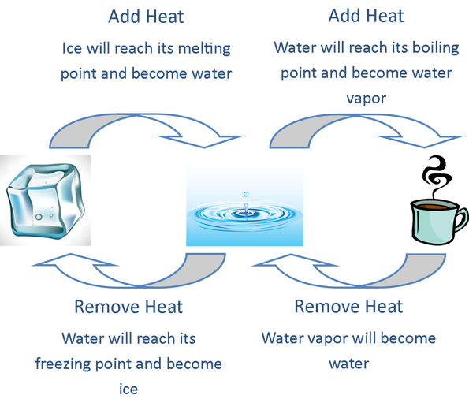
Celsius | Celsius is a unit of measurement used to measure temperature.
molecules | Molecules are the very tiny particles that make matter.
reversible | A change that can be undone and redone.
irreversible | A change that cannot be undone.

