*Waste Matters* – key vocabulary

|  |
| --- |
| REMEMBER THE FIVE Rs |
| * **Rethink** – what things do you really need? * **Refuse** plastic where you can – it can help make a point. * **Reduce** the amount of plastic you use. * **Reuse** items where you can. * **Recycle** as much as possible |
|
|
|
|

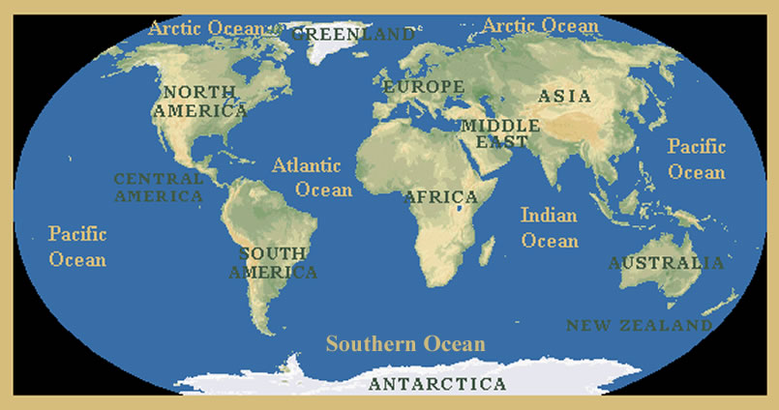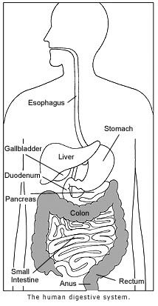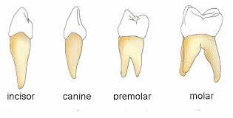

Easter

Trust

Betray

Deny

Judas

Peter

Persecute

Plastic

Pollution

Interdependence

Henderson Island

Gyre

Microbeads

Microplastic

Single use plastic

Landfill

Plaque

Decay

Carnivore

Herbivore

Omnivore

Predator

Prey

Consumer

Producer

Food chain

Digestion