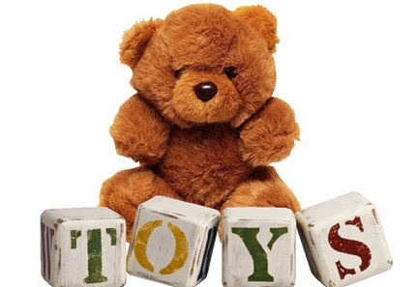
It is time to get creative! This half term for homework I would like you to do a project on Toys. You can choose from one of these ideas or do one of your own.

- Find out all about your favourite toy. How is it made? What is it made of? How long has it been created?
- Find out about the toys your parents or grandparents played with when they were young. Do they still exist? How have they changed? What were they made out of?
- Design a new toy or game?
- Choose 1 type of toy e.g. teddies or cars, and show how they have changed over the years
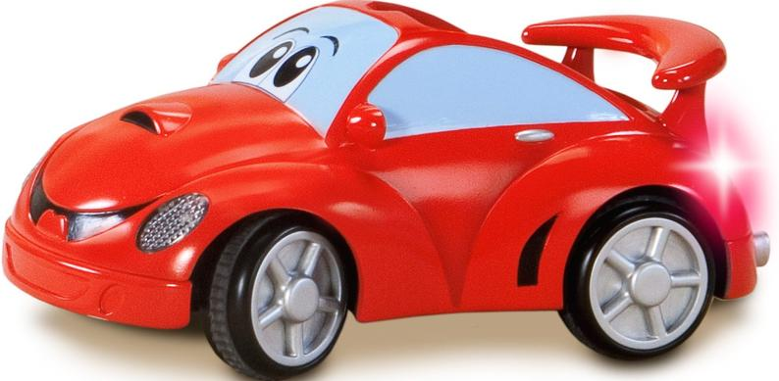
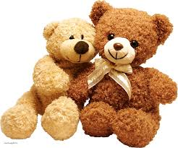
You can decide how to present your work. e.g.
- A poster
- A power point
- Make a model
- Information booklet
- Painting or drawing
- Write a story
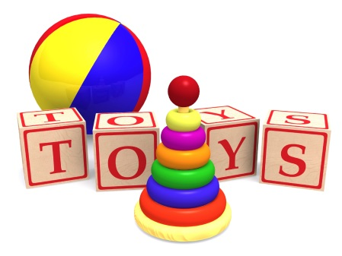
- Or an idea of your own
Be as creative as you like!
Please bring your projects in by Friday 8th February.

