The seaside
Key Vocabulary |  | Holy Day – Holiday  The word holiday comes from the words holy days!  A very long time ago, holidays were based around religious festivals.  Christmas and Easter are still religious holidays but today we have holidays to give us a rest from working hard, to spend time with our families and do the things we enjoy doing. | Victorian Times  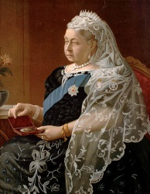  The Victorians lived over one hundred and fifty years ago during the reign of Queen Victoria (1837 to 1901).  Victorian times means during Victoria's rule. The time Queen Victoria was on the throne. She ruled for 64 years.
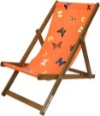 | Deckchair A fold up chair that can be taken on outings.
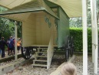 | Bathing machine A hut used to change clothes and heeled directly to the sea.
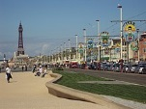 | Promenade A leisurely walk or ride especially in a public place for pleasure or display
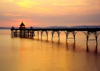 | Pier A structure that goes out to sea and can be used for walking on.
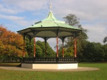 | Band stand An outdoor stage for bands to perform on. |  | Brass Bands  A group of people playing instruments that you can blow.  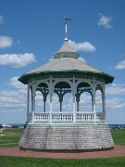  A Century  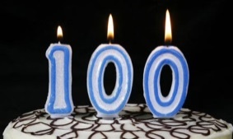  A time span of 100 years.
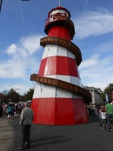 | Helter Skelter A slide made of wood. | Steam Train  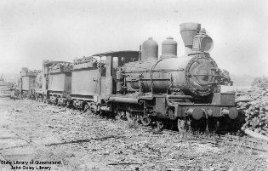  A train to take people on holiday that is powered by coal in the engine.
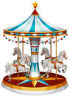 | Carousel A fairground ride with horses and music.
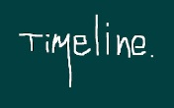 | Chronological Putting events in order. | Punch and Judy  A puppet show by the seaside.  