Castles
Key Vocabulary |  | Castles were built for the rich, often the  Monarchy - A person who reigns over a kingdom or empire such as a king or queen.  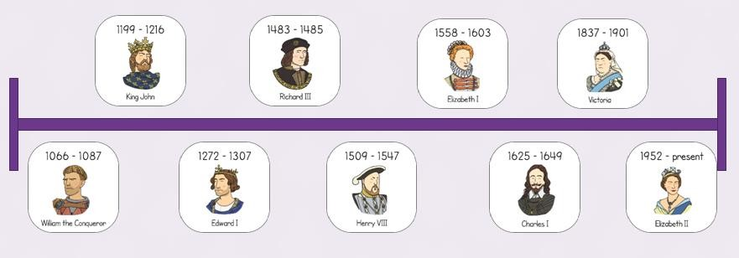  King and Queens Timeline  Many other people lived at the castle:  The Constable – in charge of the running of the castle  Soldiers – defenders of the castle  Gong Farmer – cleaning out the toilets and moat  Chef – cooking food for the family and staff  Knights - defenders of the castle | Chronology - A list of events in time order  11th century -Motte and Bailey castle  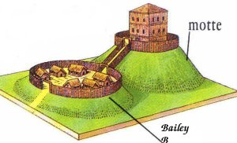  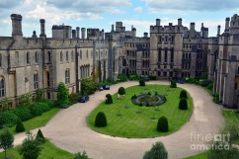  12th century – Keep and Curtain wall Castle  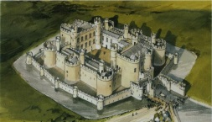  14th Century – Courtyard Castle
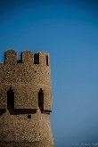 | Battlements a parapet at the top of a wall, of a castle, that has regularly spaced squared openings for shooting through
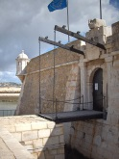 | Drawbridge a type of movable bridge at the entrance to a castle or tower surrounded by a moat
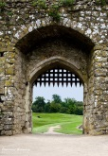 | Portcullis is a heavy sliding gate found in castles, consisting of a latticed grille made of wood or metal
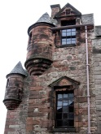 | Turret a small tower on top of a larger tower or at the corner of a building of a castle
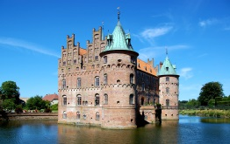 | Moat a deep ditch surrounding a castle, filled with water and intended as a defence against attack. |  | Castles were built to defend and protect.  The main building inside the castle is the keep, which was protected by walls and towers.  The first castles were built by the Normans and were called motte and bailey castles.  Castles were only as good as their defences – these included ramparts, bastions and arrow loop
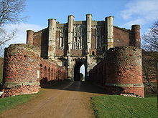 | Gatehouse an entry control point that is usually at the front of the castle and houses the Constable.
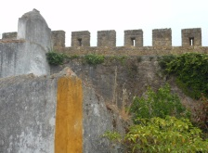 | Ramparts a defensive wall of a castle having a broad top with a walkway and typically a stone parapet.

