Autumn 2
Foundation Stage

Books we will be sharing together to help us with our learning.

- Owl Babies
- Stick Man
- Can’t You sleep Little Bear?
- Darkness Slipped In
- How to Catch a Star
- The Gingerbread Man
- The Christmas Story

People and communities ~ Visits and Visitors
- Owl Man
- Christmas Craft Afternoon
- Church for Nativity

Creative Activities
- Firework art ~ wax resist, glitter trails and pastels
- Creating our own masterpieces with paint
- Modelling with clay
- Painting using different techniques
- Making our very own Stick Man
- Observational painting of poppies
- Creating night time creatures using junk modelling
- Christmas art and craft

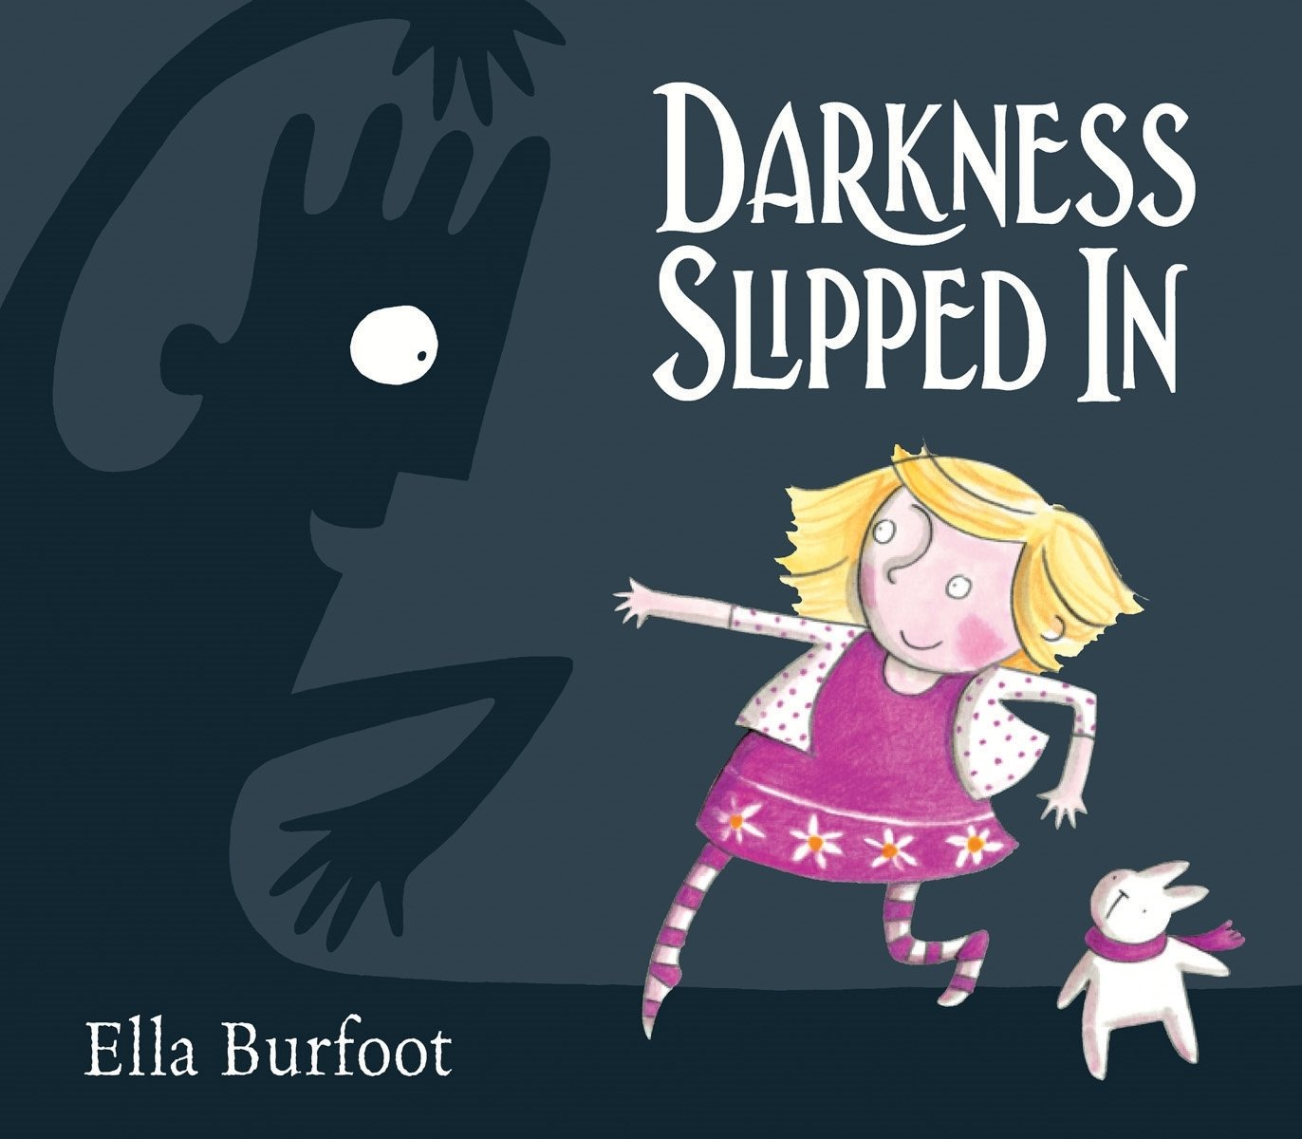
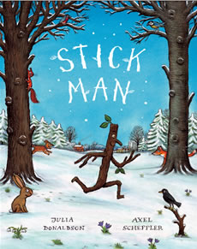

The World ~ Seasonal Changes

- Talk about dark nights and things that come out at night
- Observe changes in our local environment
- Children to find out about nocturnal animals and animals that hibernate.

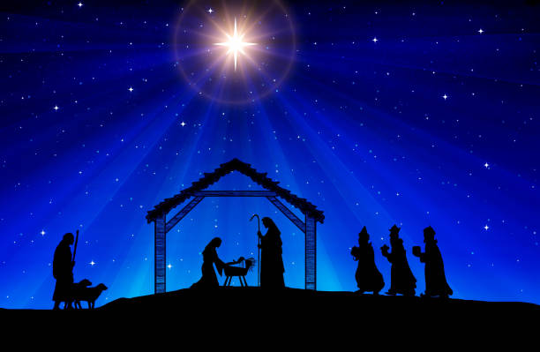
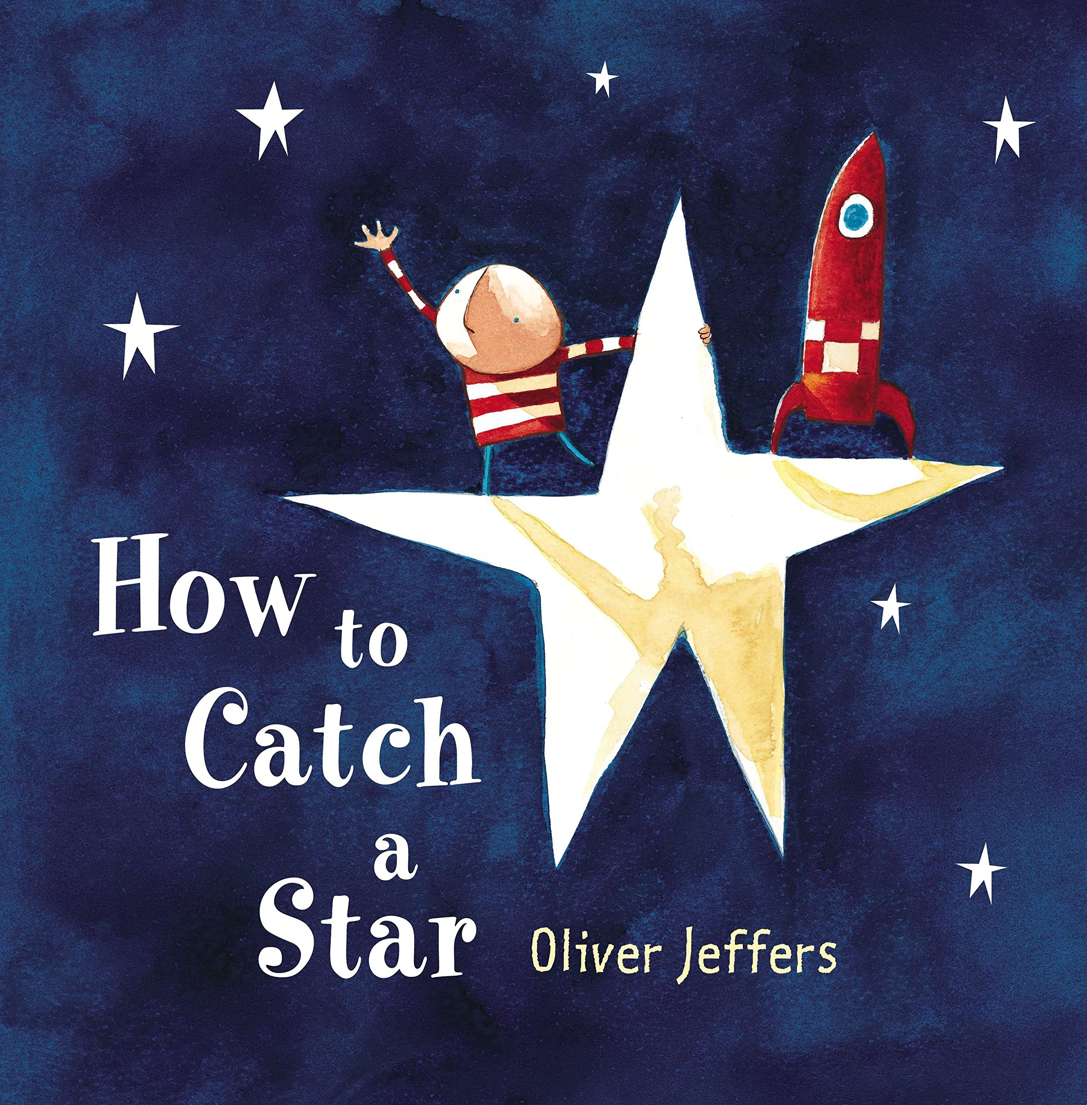
Outdoors
- Provide the children with open ended resources for them to explore, create and investigate with.
These may include: wooden blocks, crates, den making materials, outdoor sand and water, mark making equipment and areas to discover

RE ~ Christmas
- Sharing the Christmas story
- Attend Church for Nativity service
- Gifts and gift bringers
- Perform the Nativity Story

We will also be following the children’s interests and exploring the things that are of importance to them

of importance to them

